**Drop down menu**

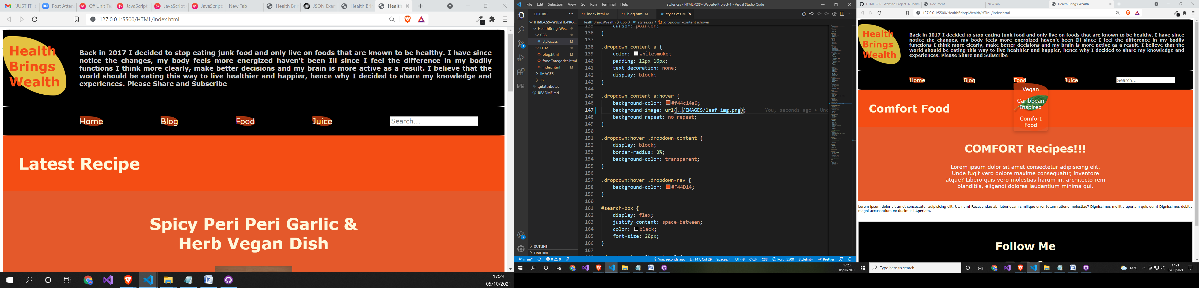

**Drop down menu clicked**

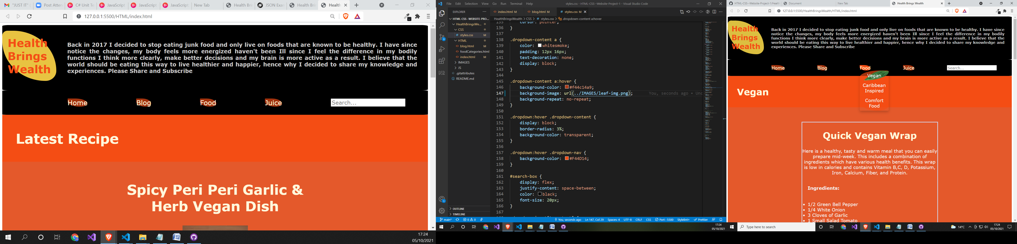

**Example of social media links**

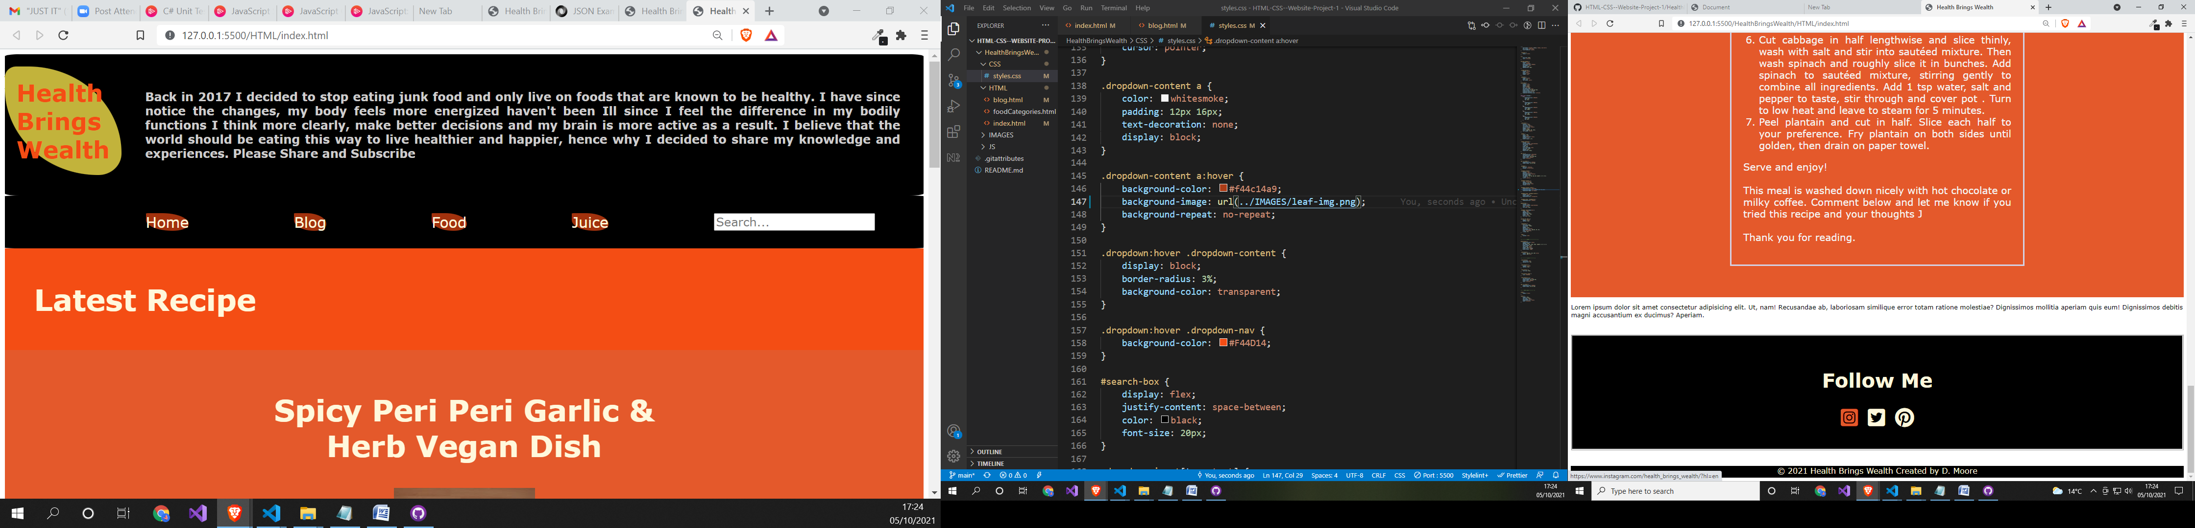

**Demari Moore**